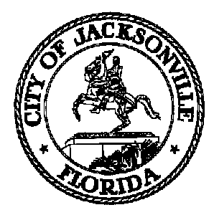
Taxation, Revenue and Utilization of
Expenditures (TRUE) Commission

Daniel Henry, Chair TRUE Commission
c/o Jeff Clements
Suite 425, City Hall
117 W. Duval Street
Jacksonville FL 32202
904-255-5137
TO: TRUE Commissioners

FR: Daniel Henry, Chair

RE: 2022 TRUE Commission Standing Meeting Notice - Amended

Notice is hereby given that the TRUE Commission will hold its 2022 monthly meetings (typically, but not always, on the first Thursday of each month) at 4:00 p.m. as follows:
January 6, 2022
February 3, 2022
March 3, 2022
April 7, 2022
May 5, 2022
June 2, 2022
July 7, 2022
August 4, 2022
September 1, 2022
October 6, 2022
November 3, 2022
December 1, 2022

The committee will normally meet in the Don Davis Room, 1st Floor, City Hall at St. James, located at 117 W. Duval Street, Jacksonville FL. Alternate dates, locations or times may be posted as necessary due to changing conditions at a later date.

Pursuant to the American with Disabilities Act, accommodations for persons with disabilities are available upon request. Please allow 1-2 business days’ notification to process; last minute requests will be accepted but may not be possible to fulfill. Please contact the Disabled Services Division at: 904-255-5466 or 904-255-5476, or email your request to KaraT@coj.net.

You may attend the meeting in-person at the physical location - Don Davis Room - but CDC guidelines will be adhered to due to COVID-19. Concurrent with the expiration of Mayor Curry's Emergency Executive Proclamation 2020-005, any member of the public entering City-owned public buildings may choose to wear a mask inside the building. Council strongly encourages the use of masks for all employees and visitors, especially when social distancing at 6 feet (or more) is not possible. Masks will be made available for members and the public.

Commission members and the public attending meetings may park in the City Hall/ Main Library parking garage at the corner of Main and Duval Streets – bring your ticket to the meeting for validation by staff.

All interested parties are invited to attend.

For further information contact Jeff Clements, Chief, City Council Research Division, at 904-255-5137 or jeffc@coj.net.

c.c. Cityc@coj.net
City Council media notice box
File copy

Jeff Clements, Council Research Division Posted 12.17.21 9:30 a.m.

